

# 

### Semester One Examination, 2018

### Question/Answer booklet

# MATHEMATICS

**SOLUTIONS**

**SPECIALIST**

**UNIT 1**

## Section One:

## Calculator-free

|  |  |  |  |  |  |  |  |  |  |  |
| --- | --- | --- | --- | --- | --- | --- | --- | --- | --- | --- |
| Student number: In figures |  |  |  |  |  |  |  |  |  |  |

In words

Your name

## Time allowed for this section

Reading time before commencing work: five minutes

Working time: fifty minutes

## Materials required/recommended for this section

***To be provided by the supervisor***

This Question/Answer booklet

Formula sheet

***To be provided by the candidate***

Standard items: pens (blue/black preferred), pencils (including coloured), sharpener,  
correction fluid/tape, eraser, ruler, highlighters

Special items: nil

## Important note to candidates

No other items may be taken into the examination room. It is **your** responsibility to ensure that you do not have any unauthorised material. If you have any unauthorised material with you, hand it to the supervisor **before** reading any further.

## Structure of this paper

|  |  |  |  |  |  |
| --- | --- | --- | --- | --- | --- |
| Section | Number of questions available | Number of questions to be answered | Working  time (minutes) | Marks available | Percentage of examination |
| Section One:  Calculator-free | 8 | 8 | 50 | 53 | 35 |
| Section Two:  Calculator-assumed | 13 | 13 | 100 | 97 | 65 |
|  | | |  | **Total** | 100 |

## Instructions to candidates

1. The rules for the conduct of examinations are detailed in the school handbook. Sitting this examination implies that you agree to abide by these rules.

2. Write your answers in this Question/Answer booklet.

3. You must be careful to confine your response to the specific question asked and to follow any instructions that are specified to a particular question.

4. Supplementary pages for the use of planning/continuing your answer to a question  
have been provided at the end of this Question/Answer booklet. If you use these pages to continue an answer, indicate at the original answer where the answer is continued, i.e. give the page number.

5. Show all your working clearly. Your working should be in sufficient detail to allow your answers to be checked readily and for marks to be awarded for reasoning. Incorrect answers given without supporting reasoning cannot be allocated any marks. For any question or part question worth more than two marks, valid working or justification is required to receive full marks. If you repeat any question, ensure that you cancel the answer you do not wish to have marked.

6. It is recommended that you do not use pencil, except in diagrams.

7. The Formula sheet is not to be handed in with your Question/Answer booklet.

Section One: Calculator-free 35% (53 Marks)

This section has**eight (****8)** questions. Answer **all** questions. Write your answers in the spaces provided.

Working time: 50 minutes.

Question 1 (5 marks)

Relative to the origin $O$, points $A$ and $B$ have position vectors $-3i-2j$ and $i-4j$ respectively.

(a) Determine the unit vector $\hat{c}$, where $c=\vec{AB}$. (3 marks)

|  |
| --- |
| **Solution** |
|  |
| **Specific behaviours** |
| ✓ vector  ✓ magnitude  ✓ unit vector, simplified |

(b) Vector $d$ has magnitude $3\sqrt{5}$, is parallel to $c$ and in the opposite direction. Determine $d$.

(2 marks)

|  |
| --- |
| **Solution** |
| $$d=3\sqrt{5}×\left(-1\right)×\frac{\sqrt{5}}{5}\left(\begin{matrix}2 \\ -1\end{matrix}\right) \\ =\left(\begin{matrix}-6 \\ 3\end{matrix}\right)$$ |
| **Specific behaviours** |
| ✓ reverses  ✓ correct vector |

Question 2 (5 marks)

Let the displacement vectors $a, b$ and $c$ be $(11, -4)$, $(5, 14)$ and $(8, m)$ respectively, where $m$ is a constant.

(a) Determine the vector $3a+2b$. (2 marks)

|  |
| --- |
| **Solution** |
| $$3a+2b=3\left(11, -4\right)+2\left(6, 14\right) \\ =\left(33, -12\right)+\left(12, 28\right) \\ =(43, 16)$$ |
| **Specific behaviours** |
| ✓ multiplies by scalar  ✓ correct vector |

(b) Given that $\left|a+b+kc\right|=0$, detemine the values of $k$ and $m$. (3 marks)

|  |
| --- |
| **Solution** |
| $$\left(\begin{matrix}11 \\ -4\end{matrix}\right)+\left(\begin{matrix}5 \\ 14\end{matrix}\right)+k\left(\begin{matrix}8 \\ m\end{matrix}\right)=\left(\begin{matrix}0 \\ 0\end{matrix}\right)$$ From $i$-coeff: $11+5+8k=0⇒k=-2$ From $j$-coeff: $-4+14-2m=0⇒m=5$ |
| **Specific behaviours** |
| ✓ vector equation  ✓ value of  ✓ value of $m$ |

Question 3 (8 marks)

Consider the following statement about a simple (no edges that cross) polygon:

*If it has an interior angle sum of 360°, then it is a square.*

(a) Use a counter-example to explain why the statement is false. (2 marks)

|  |
| --- |
| **Solution** |
| A trapezium has an interior angle sum of 360° but is not a square. |
| **Specific behaviours** |
| ✓ names or draws any quadrilateral that is not a square  ✓ uses angle sum and fact that shape is not a square |

(b) Write the converse statement and state whether it is always, sometimes or never true.

(2 marks)

|  |
| --- |
| **Solution** |
| If it is a square, then it has an interior angle sum of 360°.  The converse statement is **always** true. |
| **Specific behaviours** |
| ✓ writes converse  ✓ states always true |

(c) Write the inverse statement and state whether it is always, sometimes or never true.

(2 marks)

|  |
| --- |
| **Solution** |
| If it does not have an interior angle sum of 360°, then it is not a square.  The inverse statement is **always** true. |
| **Specific behaviours** |
| ✓ writes inverse  ✓ states always true |

(d) Write the contrapositive statement and state whether it is always, sometimes or never true. (2 marks)

|  |
| --- |
| **Solution** |
| If it is not a square, then it does not have an interior angle sum of 360°.  The contrapositive statement is **sometimes** true.  *(eg true for triangle, false for any quadrilateral)* |
| **Specific behaviours** |
| ✓ writes contrapositive  ✓ states sometimes true |

Question 4 (6 marks)

(a) Determine the value of the constant $n$, given that the vectors $12i+nj$ and $5i-8j$ are perpendicular. (2 marks)

|  |
| --- |
| **Solution** |
| $$60-8n=0$$ $$n=\frac{15}{2}=7.5$$ |
| **Specific behaviours** |
| ✓ equates scalar product to 0  ✓ solves for $n$ |

(b) The vectors $a$ and $b$ are such that $\left|a\right|=18, \left|b\right|=12$ and $a∙b=-33$. Evaluate

(i) $-2a∙3b$. (1 mark)

|  |
| --- |
| **Solution** |
| $$-33×-2×3=198$$ |
| **Specific behaviours** |
| ✓ correct value |

(ii) $\left(a+b\right)∙(b-a)$. (3 marks)

|  |
| --- |
| **Solution** |
|  |
| **Specific behaviours** |
| ✓ expands  ✓ simplifies to difference of squares  ✓ correct value |

Question 5 (7 marks)

(a) In the diagram below, the vertices of triangle $ABC$ lie on a circle with centre $O$. Given that $∠ABC=54°$, determine the values of $∠AOC$ and $∠OAC$. (2 marks)

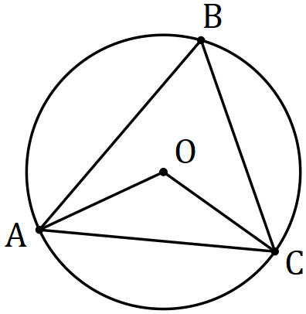

|  |
| --- |
| **Solution** |
| $$∠AOC=2×54=108°$$ $$∠OAC=\frac{180-108}{2}=36°$$ |
| **Specific behaviours** |
| ✓ first angle  ✓ second angle |

(b) Prove, assuming only basic axioms and properties of triangles, that the size of the angle subtended by an arc at the centre of a circle is twice the size of the angle subtended at any point on the circumference by the same arc. (5 marks)

|  |
| --- |
| **Solution** |
| Required to prove that $a=2b$ Let $b=∠OQP+∠OQR$ But $∠OQP=∠OPQ$ and $∠OQR=∠ORQ$ (isosceles triangles)  And so $∠QOP=180-2∠OQP$ and $∠QOR=180-2∠OQR$ $$\text{At} O, a=360-∠QOP-∠QOR \\ a=360-\left(180-2∠OQP \right)-\left(180-2∠OQR\right) \\ a=2(∠OQP+∠OQR) \\ a=2b, \text{as required}.$$ |
| **Specific behaviours** |
| ✓ labelled diagram(s) illustrating RTP  ✓ uses isosceles triangles  ✓ expressions for angles at  ✓ equation using angle sum at a point  ✓ substitutes and simplifies |

Question 6 (6 marks)

A drone leaves point $P$ and travels $115$ m on bearing of $340°$ to $Q$, then $30$ m on bearing $070°$ to $R$ and finally $85$ m on bearing $160°$ to $S$.

(a) Sketch a neat diagram to show the path of the drone. (2 marks)

|  |
| --- |
| **Solution** |
|  |
| **Specific behaviours** |
| ✓ first leg, labelled  ✓ other legs and labels |

(b) The drone is to return directly from $S$ to $P$. Determine the distance it must fly and on what bearing. (4 marks)

|  |  |
| --- | --- |
| **Solution** | |
|  | $$PS=30\sqrt{2} \text{m}$$ $$∠SPT=45°$$ $$\text{Bearing is }180+\left(45-20\right)=205°$$ |
| **Specific behaviours** | |
| ✓ simplified sketch of return leg [or seen in (a)]  ✓ correct distance  ✓ indicates angle of $45°$ in triangle  ✓ correct bearing | |

Question 7 (9 marks)

(a) Evaluate $^{16}P_{11}÷ ^{14}P_{11}$. (3 marks)

|  |
| --- |
| **Solution** |
| $$\frac{16!}{5!}×\frac{3!}{14!}=\frac{16×15}{5×4}=12$$ |
| **Specific behaviours** |
| ✓ expresses using factorials  ✓ eliminates factorials  ✓ evaluates |

(b) Express $9!+8!+7!$ in the form $a^{2}b!$, where $a$ and $b$ are positive integers. (3 marks)

|  |
| --- |
| **Solution** |
| $$9!+8!+7!=\left(9×8+8+1\right)×7!$$ $$=81×7!$$ $$=9^{2}×7!$$ |
| **Specific behaviours** |
| ✓ factors out lowest factorial  ✓ simplifies  ✓ writes in required form |

(c) Show that for $n∈Z, n≥3$, the sum $n!+\left(n-1\right)!+\left(n-2\right)!$ can always be expressed in the form $a^{2}b!$ where $a$ and $b$ are positive integers. (3 marks)

|  |
| --- |
| **Solution** |
| $$n!+\left(n-1\right)!+\left(n-2\right)!=\left(\left(n\right)\left(n-1\right)+\left(n-1\right)+1\right)\left(n-2\right)! \\ =\left(n^{2}-n+n-1+1\right)\left(n-2\right)! \\ =n^{2}\left(n-2\right)!$$ $$(a=n \text{and} b=n-2)$$ |
| **Specific behaviours** |
| ✓ uses $\left(n-2\right)!$ as one factor  ✓ clearly shows composition of second factor  ✓ simplifies second factor and writes as required |

Question 8 (7 marks)

In the diagram below, two chords of a circle, $BC$ and $DE$, intersect at $F$. $GB$ is perpendicular to $BC$ at $B$ and $GE$ is perpendicular to $DE$ at $E$. The line $GF$ intersects chord $CD$ at $H$.

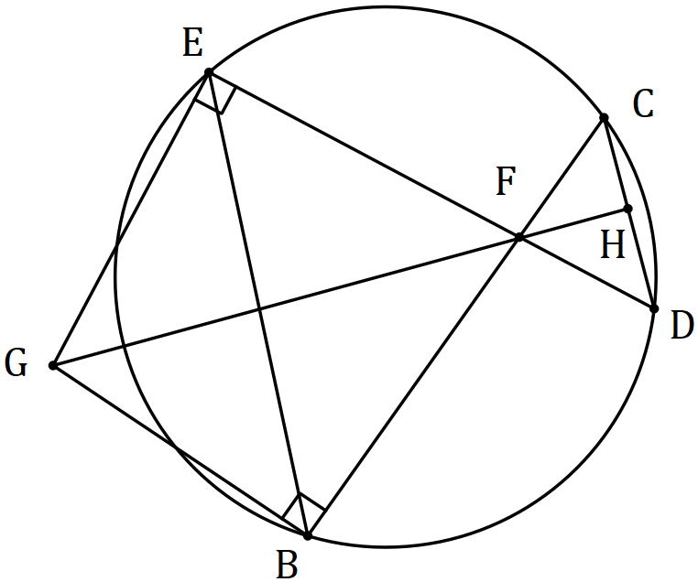

(a) Explain why $GEFB$ is a cyclic quadrilateral. (1 mark)

|  |
| --- |
| **Solution** |
| Sum of opposite angles $∠GEF+∠FBG=180°$. |
| **Specific behaviours** |
| ✓ explanation using opposite angles and their sum |

(b) Prove that $∠CDE=∠EGF$. (3 marks)

|  |
| --- |
| **Solution** |
| $$∠CDE=∠CBE \text{(common arc} EC\text{)}$$ $$∠EGF=∠EBF \text{(common arc} EF)$$ $$\text{Hence }∠CDE=∠EGF \text{(since} ∠CBE \text{and} ∠EBF \text{are same angle)}$$ |
| **Specific behaviours** |
| ✓ uses circle shown  ✓ uses circle from (a)  ✓ reasoning |

(c) Prove that $GH$ is perpendicular to $CD$. (3 marks)

|  |
| --- |
| **Solution** |
| $$∠EFG=∠HFD \text{(Vert Opp)}$$ $$\text{Hence} ⊿EGF\sim ⊿HDF \text{(AA)}$$ $$∠FHD=∠FEG=90°⇒⊥$$ |
| **Specific behaviours** |
| ✓ uses vertically opposite angles  ✓ uses AA for similarity  ✓ deduces perpendicular |

Supplementary page

Question number: _________

© 2018 WA Exam Papers. Baldivis Secondary College has a non-exclusive licence to copy and communicate this document for non-commercial, educational use within the school. No other copying, communication or use is permitted without the express written permission of WA Exam Papers. SN261-111-2.